The ‘this’ pointer

Task 1
When using classes, code has a special variable called ‘this’. This is a pointer to the class itself. The pointer can be used to specify that the item to be accessed is a member of the class. The variable can be used by some development environments to provide forward lookup assistance. This can be used to assist the developer to find the items of a class, when this and ‘->’ are used together the environment will provide a list of possible properties or functions.

Why do you need this?
The example code below has a few places in which a ‘this’ pointer is required to distinguish between a local variable and a class member with the same name. This clash of variable names is something that should be generally avoided. The class used to illustrate this has four member variables a Boolean bCopy, an integer count, an integer copy count and a character array name.
There are three versions of the constructor each takes different parameters.
The first takes a number and a pointer to a character array. This version sets copy as false; the count to the number, the copy count to 0 and string copies the name then concatenates a string version of the number.
The second takes a pointer to a CTask1 class. This version of constructor can be used to copy. The bCopy is set to true, the number to the number, the copy count is copied, then the original is incremented and the name is constructed from "Copy of <" the name then ">".
The third and final constructer takes a pointer to a character array called name, the name is string copied in to the class member name. Other items are set to false zero and one.

Header Code
The following class definition is required in the header file.
#include “string.h”
#include “conio.h”
class CTask1
{
public:
CTask1(const int count, const char * name);
CTask1(CTask1 * item);
CTask1(const char * name);
virtual ~CTask1();
void display(void);
private:
char name[80];
int count;
int copycount;
bool bCopy;
};

Declaration code
#include "Task1.h"

int main(int argc, char* argv[])
{
CTask1 First("One");
CTask1 Second(&First), * List[16];
int i;
First.display();
Second.display();
printf("\n");
//Allocate list elements
List[0] = new CTask1(&Second);
List[0]->display();
for(i=1;i<16;)
{
List[i] = new CTask1(i,"Count");
List[i++]->display();
List[i] = new CTask1(List[i/4]);
List[i++]->display();
List[i] = new CTask1("name List");
List[i++]->display();
}
getch();
//display again
printf("\n\n\n");
First.display();
Second.display();
printf("\n");
for(i=0;i<16;)
{
List[i]->display();
delete List[i++]; //free memory
}
getch();
return 0;
}
//////////////////////////////////////////////////////////////////////
// CTask1 Class
//////////////////////////////////////////////////////////////////////
//////////////////////////////////////////////////////////////////////
// Construction/Destruction
//////////////////////////////////////////////////////////////////////
CTask1::CTask1(const int count, const char *name)
{
char temp[10];
sprintf(temp,"%7d",count);
bCopy =false;
this->count = count;
this->copycount = 0;
strncpy(this->name,name,sizeof(this->name)-8);
strcat(this->name,temp);
}
// Copy Contructor
CTask1::CTask1(CTask1 * item)
{
this->bCopy = true;
this->count = item->count;
this->copycount = item->copycount;
item->copycount++;
strcpy(this->name,"Copy of <");
strncat(this->name,item->name,sizeof(this->name)-9);
strcat(this->name,">");
}
CTask1::CTask1(const char * name)
{
this->bCopy = false;
this->count = 1;
this->copycount =0;
strcpy(this->name,name);
}
CTask1::~CTask1()
{
}
void CTask1::display()
{
printf("Task 1 ");
printf("%s ",bCopy?"Copy":" ");
printf("Copies %2d ", copycount);
printf("Count %2d ",count);
printf("Name:%s\n",name);
}

Where is this required
There are a number of places in the code above, where the 'this' pointer is required. They are as follows.
- In the number and name constructor where the name and counter values are referenced. With out the 'this' in front of the variables the program will assume the item is the local variable version and not the class variable.
- The copy constructor version does not need to use the ‘this’ pointer, as there are no clashing variable names. The major reason for using ‘this’ is to clarify that the data is being written to the class members.
- In the name constructor version the pointer is only required for the string copy operations as this is the only item that has a clash, but it is used with the others to clarify the operations being under taken.

Appearance of Output First screen
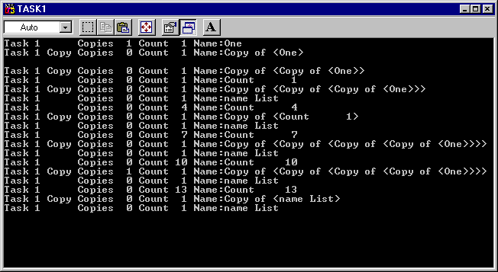

Appearance of Output Second screen
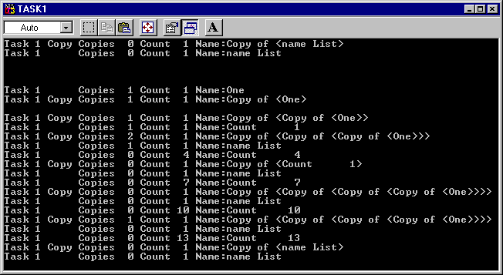

Exercise
Look at the use of the ‘this’ pointer to clarify the meaning of code in previous project for level two C++.

